# **Spread of a Data Set**

Students learn how to evaluate the spread of a quantitative column using box plots, and explore how this offers a different perspective on shape from what can be achieved with a histogram. After applying these concepts to a contrived dataset, they apply them to their own datasets and interpret the results.

| **Prerequisites** | [Measures of Center](https://bootstrapworld.org/materials/spring2021/en-us/courses/data-science/lessons/ds-measures-of-center/index.shtml) |
| --- | --- |
| **Relevant Standards** | *Common Core Math Standards*  **6.SP.A**  Develop understanding of statistical variability.  **6.SP.A.2**  Understand that a set of data collected to answer a statistical question has a distribution which can be described by its center, spread, and overall shape.  **6.SP.B.4**  Display numerical data in plots on a number line, including dot plots, histograms, and box plots.  **6.SP.B.5**  Summarize numerical data sets in relation to their context.  **6.SP.B.5.C**  Summarize numerical data sets in relation to their context by giving quantitative measures of center (median and/or mean) and variability (interquartile range and/or mean absolute deviation), as well as describing any overall pattern and any striking deviations from the overall pattern with reference to the context in which the data were gathered.  **HSS.ID.A.1**  Represent data with plots on the real number line (dot plots, histograms, and box plots).  **HSS.ID.A.2**  Use statistics appropriate to the shape of the data distribution to compare center (median, mean) and spread (interquartile range, standard deviation) of two or more different data sets.  **MP.3**  Construct viable arguments and critique the reasoning of others  **MP.4**  Model with mathematics  *Next-Gen Science Standards*  **HS-SEP4-2**  Apply concepts of statistics and probability (including determining function fits to data, slope, intercept, and correlation coefficient for linear fits) to scientific and engineering questions and problems, using digital tools when feasible. |
| **Lesson Goals** | Students will be able to…​   * apply one approach to measuring and displaying spread of a data set * compare and contrast information displayed in a box plot and a histogram |
| **Student-facing Lesson Goals** | * Let’s compare different uses for box plots and histograms when talking about data. |
| **Materials** | * [Google Slides](https://docs.google.com/presentation/d/1rEa3AcS87IWHgHm7epwYp6QMbALbTPFkJpnWn0byqNg/) * [Animals Starter File](https://code.pyret.org/editor#share=1ZupMVPWvVUOM0HCWyA7cRBghSLKxPWv1) * [Interpreting Spread (Page 62)](https://bootstrapworld.org/materials/spring2021/en-us/courses/data-science/lessons/ds-measures-of-spread/pages/interpreting-spread.html) * [Identifying Shape (Page 63)](https://bootstrapworld.org/materials/spring2021/en-us/courses/data-science/lessons/ds-measures-of-spread/pages/identifying-shape.html) * [Shape of My Dataset (Page 64)](https://bootstrapworld.org/materials/spring2021/en-us/courses/data-science/lessons/ds-measures-of-spread/pages/shape-of-my-dataset.html) * [Matching Box-Plots to Histograms (Page 65)](https://bootstrapworld.org/materials/spring2021/en-us/courses/data-science/lessons/ds-measures-of-spread/pages/matching-boxplots-to-histograms.html) * [*Summarizing Columns in the Animals Dataset (Page 61)*](https://bootstrapworld.org/materials/spring2021/en-us/courses/data-science/lessons/ds-measures-of-center/pages/summarizing-columns-in-animals.html) * [*Matching Vocabulary to Definitions (Desmos)*](https://teacher.desmos.com/activitybuilder/custom/5fe89eeaaef67d0cea85ba5e) |
| **Preparation** | * Make sure all materials have been gathered * Decide how students will be grouped in pairs * Computer for each student (or pair), with access to the internet * [Student workbook](https://bootstrapworld.org/materials/spring2021/en-us/courses/data-science//workbook/workbook.pdf), and something to write with * All students should log into [CPO](https://code.pyret.org/) and open the "Animals Starter File" they saved from the prior lesson. If they don’t have the file, they can [open a new one](https://code.pyret.org/editor#share=1ZupMVPWvVUOM0HCWyA7cRBghSLKxPWv1) |
| **Supplemental Resources** | **Summative Assessments / Capstone:**  [Stress Project](https://bootstrapworld.org/materials/spring2021/en-us/courses/data-science/lessons/ds-measures-of-spread/pages/stress-project.html) (You will also need the [Personality True Colors assessment](https://bootstrapworld.org/materials/spring2021/en-us/courses/data-science/lessons/ds-measures-of-spread/pages/personality-colors.pdf)) |
| **Language Table** | | Types | Functions | Values | | --- | --- | --- | | **Number** | num-sqrt, num-sqr, mean, median, modes | 4, -1.2, 2/3 | | **String** | string-repeat, string-contains | "hello", "91" | | **Boolean** | ==, <, <=, >=, string-equal | true, false | | **Image** | triangle, circle, star, rectangle, ellipse, square, text, overlay, bar-chart, pie-chart, bar-chart-summarized, pie-chart-summarized, histogram | 🔵🔺🔶 | | **Table** | count, .row-n, .order-by, .filter, .build-column |  | |

***Glossary***

**box plot** the box plot (a.k.a. box-and whisker-plot) is a way of displaying a distribution of data based on the five-number summary: minimum, first quartile, median, third quartile, and maximum **histogram** a display of quantitative data that uses vertical bars positioned over bins (sub-intervals); each bar’s height reflects the count or percentage of data values in that bin. **interquartile range** (IQR) is one possible measure of spread, based on dividing a data set into four parts. The values that divide each part are called the first quartile (Q1), the median, and third quartile (Q3). IQR is calculated as Q3 minus Q1. **median** the middle element of a quantitative data set **quartiles** three values that divide a data set into four equal-sized groups **range of a data set** the distance between minimum and maximum values **sample** a set of individuals or objects collected or selected from a statistical population by a defined procedure **shape** The aspect of a dataset that tells which values are more or less common **spread** the extent to which values in a data set vary, either from one another or from the center

## Measures of Spread

## 30 minutes

### *Overview*

Students are introduced to the notion of *spread* in a dataset. They learn about quartiles, box plots, and how to use them to talk about spread.

### *Launch*

A teacher may report that her students averaged a 75 on a test, but it’s important to know how those scores were spread out: did all of them get exactly 75, or did half score 100 and the other half 50? When Data Scientists use the mean of a sample to estimate the mean of a whole population, it’s important to know the spread in order to report how good or bad a job that estimate does.

Suppose we lined up all of the values in the pounds column of the animals data set from smallest to largest, and then split the line up into two equal groups by taking the ***median***. We can learn something about the ***spread*** of the data set by taking things further: The middle of the lighter half of animals is called the first ***quartile*** - or "Q1" - and the middle of the heavier half of animals is the third quartile (also called "Q3"). Once we find these numbers, we can say that the middle half of the animals’ weights are spread between Q1 and Q3.

The first quartile (Q1) is the value for which 25% of the animals weighed that amount or less. What does the third quartile represent?

Besides looking at the median as center, and the spread between Q1 and Q3, we also gain valuable information from the spread of the entire data set—that is, the distance between minimum and maximum. This is called the ***range of a data set***. (**Note**: the term “Range” means something different in statistics than it does in algebra and programming!)

We can use ***box plots*** to visualize all of this information. These plots are constructed using **just five numbers**, which makes them convenient ways to display both center and spread of a data set in a clear and simple way. Below is the contract for box-plot, along with an example that will make a box plot for the pounds column in the animals-table.

# box-plot :: (t :: Table, column :: String) -> Image

box-plot(animals-table, "pounds")

Box plots divide our sample into equally-sized groups, and show where those groups are spread thin or clumped together.

Type in this expression in the Interactions Area, and see the resulting plot.

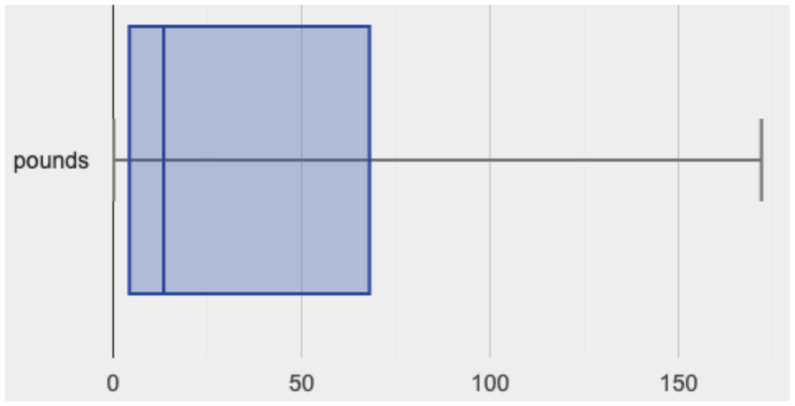

This plot shows us the center and spread in our dataset according to those five numbers.

* The **minimum** value in the dataset (at the left of “whisker”). In our dataset, that’s just 0.1 pounds.
* The **First Quartile (Q1)** (the left edge of the box), is computed by taking *the median of the lower half of the values*. In the pounds column, that’s 3.9 pounds.
* The **Median** value (the line in the middle), which is the middle Quartile of the whole dataset. We already computed this to be 11.3 pounds.
* The **Third Quartile (Q3)** (the right edge of the box), which is computed by taking *the median of the upper half of the values*. That’s 60.4 pounds in our dataset.
* The **maximum** value in the dataset (at the right of the “whisker”). In our dataset, that’s 172 pounds.

### *Investigate*

* Turn to [Summarizing Columns in the Animals Dataset (Page 61)](https://bootstrapworld.org/materials/spring2021/en-us/courses/data-science/lessons/ds-measures-of-center/pages/summarizing-columns-in-animals.html)
* Fill in the five-number summary for the pounds column, and sketch the box plot.
* What conclusions can you draw about the distribution of values in this column?

Data Scientists subtract the 1st quartile from the 3rd quartile to compute the range of the “middle half” of the dataset, also called the ***interquartile range***.

| **Kinesthetic Activity**  Divide the class into groups, and give each group a ruler and a ball of playdough. Have them draw a number line from 0-6 with the ruler, marking off the points at 0, 3, 4, 4.5 and 6 inches. Have the groups roll the dough into a thick cylinder, divide that cylinder in half, and then split each half to form four *equally-sized cylinders*. The playdough represents a ***sample***, with values divided into four ***quartiles***.  Box plots stretch and squeeze these equal quartiles across a number line, so that each quartile fills up an interval in that quartile. On their number line, students have intervals from 0-3, 3-4, 4-4.5, and 4.5-6. Have students roll their cylinders so that they fill each of these intervals, retaining a uniform thickness.  They should notice that shorter intervals have *thicker cylinders*, and longer ones have skinny ones. Even though a box plot doesn’t show us the thickness of the data points, we can tell that a small interval has the same amount of data "squeezed" into it as a large interval. |
| --- |

* Find the ***interquartile range*** of this dataset.
* What percentage of animals fall within the interquartile range?
* What percentage of animals fall below the First Quartile? Above the Third Quartile? What percentage falls anywhere between the minimum and the maximum?

Now that you’re comfortable creating box plots and looking at measures of spread on the computer, it’s time to put your skills to the test!

Turn to [Interpreting Spread (Page 62)](https://bootstrapworld.org/materials/spring2021/en-us/courses/data-science/lessons/ds-measures-of-spread/pages/interpreting-spread.html) and complete the questions you see there.

Just as pie and bar charts are ways of visualizing categorical data, box plots and histograms are both ways of visualizing the shape of quantitative data. Box plots make it easy to see the 5-number summary, and compare the Range and Interquartile Range. Histograms make it easier to see skewness and more details of the shape, and offer more granularity when using smaller bins.

Left-skewness is seen as a long tail in a histogram. In a box plot, it’s seen as a longer left "whisker" or more spread in the left part of the box. Likewise, right skewness is shown as a longer right "whisker" or more spread in the right part of the box.

Box plots and Histograms can both tell us a lot about the shape of a dataset, but they do so by grouping data quite differently. A box plot is always divided into four parts, which may fall on differently-sized intervals but all contain the same number of points. A histogram, on the other hand, has identically-sized intervals which can contain very different numbers of points.

Turn to [Identifying Shape (Page 63)](https://bootstrapworld.org/materials/spring2021/en-us/courses/data-science/lessons/ds-measures-of-spread/pages/identifying-shape.html) and see if you can describe box plots using what you know about skewness.

**Challenge Questions:** - Compare the histograms for the pounds column of both cats and dogs in the dataset. Are their shapes different? How much overlap is there? - Compare the histograms for the age column of both cats and dogs in the dataset. Are their shapes different? How much overlap is there? - Can you explain why the amount of overlap between these two distributions is different?

### *Possible Misconceptions*

It is extremely common for students to forget that every quartile *always* includes 25% of the dataset. This will need to be heavily reinforced.

### *Synthesize*

Histograms, box plots, and measures of center and spread are all different ways to get at the ***shape*** of our data. It’s important to get comfortable using every tool in the toolbox when discussing shape!

| **Modified Box Plots**  More Statistics- or Math-oriented classes will also be familiar with *modified box plots* ([video explanation](https://www.youtube.com/watch?v=Cm_852R8JPw)), which remove outliers from the box-and-whisker and draw them as asterisks outside of the plot. Modified box plots are also available in Bootstrap:Data Science, using the following contract:  # modified-box-plot :: (t :: Table, column :: String) -> Image |
| --- |

## Comparing Box Plots

## 15 minutes

### *Overview*

Students assess the degree of visual overlap of two numerical distributions.

### *Launch*

*"Do dogs take longer to get adopted than cats?"*

This is asking us about the interaction between a categorical variable (species) and a quantitative one (weeks). Instead of creating a whole new display, all we have to do is make *separate* box plots for the distribution of weeks for both cats and dogs. Note: this works fine as long as we’re sure to use a common scale! Both box plots (see below) share the same axis for adoption times, which ranges from about 1 to 10 weeks.

Box plots make it easy to decide if values of a quantitative variable seem to be mostly similar or mostly different, depending on which group an individual is in. The trick is to train your eyes to look for whether there’s a lot of overlap in the two box plots, or if one is noticeably higher than the other.

### *Investigate*

Have students break into groups of 3-4, and compare the box plot of weeks-to-adoption for cats with the one for dogs. **Note:** they can generate the pair of box plots themselves, but we recommend simply giving them this image:

cats v. dogs

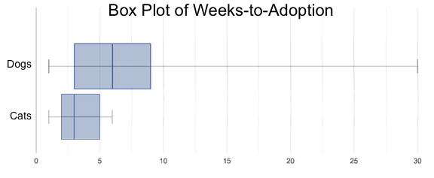

1. Do the two box plots mostly overlap, or does one have a noticeably different range than the other?
2. How do the medians compare?

Next, each group examines the pair of box plots that compare weeks to adoption for fixed versus unfixed animals:

fixed v. unfixed

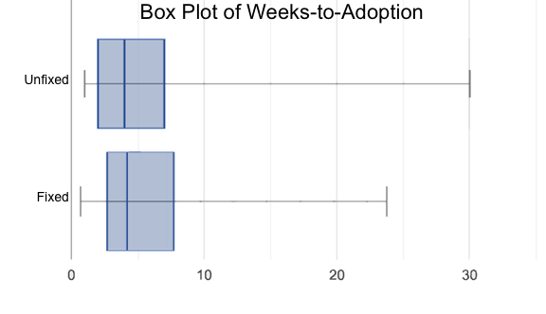. Once again, consider how similar or different the two plots seem.

1. Do the two box plots mostly overlap, or does one have a noticeably different range than the other?
2. How do the medians compare?

Students should confirm that the box plots for adoption times of unfixed versus fixed animals have more overlap than the box plots for adoption times of cats versus dogs.

Box plots create *varying-size* bins, which contain a fixed number of datapoints.

This is in contrast to ***histograms***, which have *fixed-size* bins with varying numbers of datapoints. We can imagine the data as being a pile of pizza dough, divided into four equally-sized quartiles. When the data is tightly packed, the bin is narrow. When it’s spread out, the bin is wide. Histograms show data clusters as tall bars, whereas box plots show clusters as narrow quartiles.

Box plots and histograms give us two different views on the concept of shape.

**Histograms:** fixed intervals (“bins”) with variable numbers of data points in each one. Points “pile up in bins”, so we can see how many are in each. *Larger bars show where the clusters are.*

**Box plots:** variable intervals (“quartiles”) with a fixed number of data points in each one. Treats data more like “pizza dough”, dividing it into four equal quarters showing where the data is tightly clumped or spread thin. *Smaller intervals show where the clusters are.*

To make connections between histograms and box plots, complete [Matching Box-Plots to Histograms (Page 65)](https://bootstrapworld.org/materials/spring2021/en-us/courses/data-science/lessons/ds-measures-of-spread/pages/matching-boxplots-to-histograms.html).

### *Synthesize*

Referring to our Dogs v. Cats box plots, the dogs’ adoption times were much higher than the cats’; the top half of the dogs’ box plot doesn’t overlap at all with the cats’ box plot. Does this suggest that species *does* or *does not* play a role in how long it takes for an animal to be adopted?

Referring to our Fixed v. Unfixed box plots, we saw that adoption times for unfixed and fixed animals overlapped a lot, and the medians were pretty close. Does this suggest that being fixed *does* or *does not* play a role in how long it takes for an animal to be adopted?

Which variable seems to have more of an effect on adoption time: species (cat or dog) or whether an animal is fixed or not? Have students share back their findings.

| **Project Option: Stress or Chill?**  Students can gather data about their own lives, and use what they’ve learned in the class so far to analyze it. This project can be used as a mid-term or formative assessment, or as a capstone for a limited implementation of Bootstrap:Data Science. The project description is [available here](https://bootstrapworld.org/materials/spring2021/en-us/courses/data-science/lessons/ds-measures-of-spread/pages/stress-project.html) (You will also need the [Personality True Colors assessment](https://bootstrapworld.org/materials/spring2021/en-us/courses/data-science/lessons/ds-measures-of-spread/pages/personality-colors.pdf))  *(Based on the What Stresses Us? project from* [*IDS at UCLA*](https://www.introdatascience.org/)*)* |
| --- |

## Your Analysis

## flexible

### *Overview*

Students repeat the previous activity, this time applying it to their own dataset and interpreting their own results. **Note: this activity can be done briefly as a homework assignment, but we recommend giving students an *additional class period* to work on this.**

### *Investigate*

* Take 15 minutes to fill out [Shape of My Dataset (Page 64)](https://bootstrapworld.org/materials/spring2021/en-us/courses/data-science/lessons/ds-measures-of-spread/pages/shape-of-my-dataset.html) in your Student Workbook. Choose a column to investigate, and write up your findings.
* Students should fill in [Measures of Center and Spread](https://docs.google.com/document/d/1_ZEIgM4zvxI7JizViVFZojnpd3Yr2rYe8puPk8pjOcs/edit#heading=h.bercj2qohd7o) portion of their Research Paper, using the means, medians, modes, box plots and five-number summaries they’ve constructed for their dataset and explaining what they show.

### *Synthesize*

Have students share their findings with one another.

## [🔗](https://bootstrapworld.org/materials/spring2021/en-us/courses/data-science/lessons/ds-measures-of-spread/index.shtml#_additional_exercises)Additional Exercises:

* [Matching Vocabulary to Definitions (Desmos)](https://teacher.desmos.com/activitybuilder/custom/5fe89eeaaef67d0cea85ba5e)